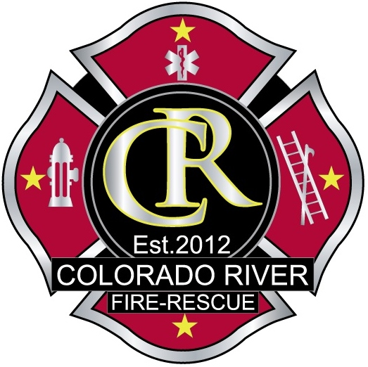  - 2020 |  | - Auto-X WEST
Hosted by Colorado River Fire Rescue |  | Vehicle extrication

Friday 17:00-20:30
Saturday 08:00-17:00
Sunday 08:00-15:00
Location
Station 41 training grounds
1850 Railroad Avenue
Rifle, CO
970-625-1243

Lunch provided SAT & SUN
Class limited to 34 students
Registration deadline April 30
Registration: $250
Online registration:
https://www.colorado.gov/pacific/crfr/trainings-0

For more information or questions email or call:
bill.smith@crfr.us
970-625-1243
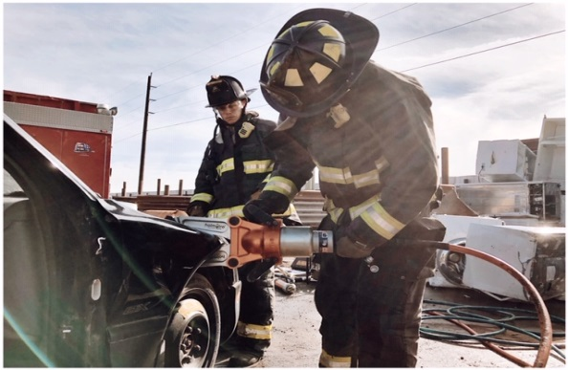

Dates: May 29-31, 2020

Complex extrication
Focus is on “small crew”/rural extrication and stabilization operations. 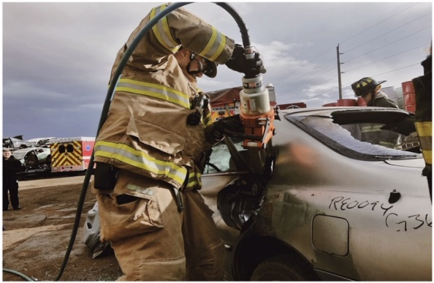
Extrication basics
Opportunities to: Learn different techniques. Utilize new tools. Hone your extrication skills.

